

**SPARQL QUERIES**

PREFIX rdf: <http://www.w3.org/1999/02/22-rdf-syntax-ns#>

PREFIX owl: <http://www.w3.org/2002/07/owl#>

PREFIX rdfs: <http://www.w3.org/2000/01/rdf-schema#>

PREFIX xsd: <http://www.w3.org/2001/XMLSchema#>

PREFIX domain: <http://movies.example.com/>

PREFIX rat: <http://ratings.example.com/>

PREFIX act: <http://actors.example.com/>

PREFIX dc: <http://purl.org/dc/terms/>

1. *Query 1: The name of the film with the most reviews*  
   select (MAX(?total_ratings) as ?max) ?name where {

?movies rdfs:label ?name.

?ratings rat:total_ratings ?total_ratings.

} group by ?name

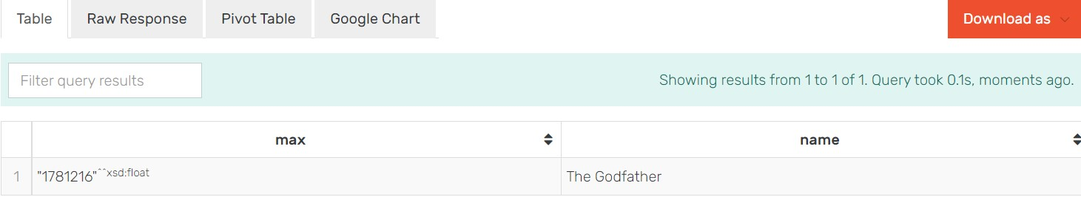

1. Query 2: *The name of the actor who has the highest overall average terms*

*ratings (sum of the average ratings of his films to the average rating of the*

*number of his films)*

select (MAX (?val) AS ?max_ratings) ?actor_name where {

?x act:primaryName ?actor_name.

?d act:KnownForTitles ?Movies_actor.

?s rat:total_ratings ?val.

?ratings rat:total_ratings ?total_ratings.

filter (?d/?s)

} group by ?actor_name

1. Query 3: *The average duration of each actor's films*select (AVG (?val) AS ?total) ?actor_name where {

?x act:primaryName ?actor_name.

?x act:KnownForTitles ?Movies_actor.

?s domain:runtimeMinutes ?val.

} group by ?actor_name LIMIT 7

